CENWP-OD-B 12 July 2023

MEMORANDUM FOR THE RECORD

SUBJECT: 23BON054 MFR BI LPS RB2 Pacific Lamprey Mort

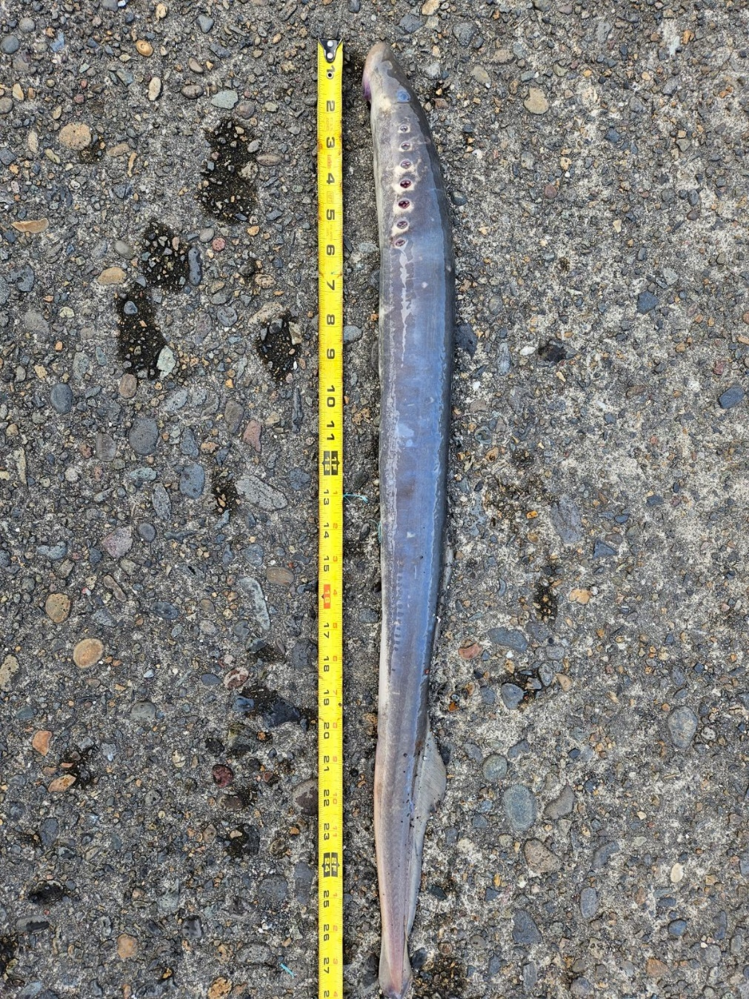
On the morning of 11 July, Project Biologists discovered one adult Pacific Lamprey mortality in the Bradford Island LPS Rest Box 2 (BI LPS RB2). The fish was scanned for PIT tags, inspected, and returned to the river.

- Species – Pacific Lamprey (Entosphenus tridentatus)
- Origin – Unknown
- Length – 71.1 cm
- Marks and tags – None
- Marks and Injuries found on carcass – None
- Cause and Time of Death – Unknown
- Future and Preventative Measures – None

Sincerely,
Bonneville Project Fisheries

